JAGANNATH INTERNATIONAL MANAGEMENT SCHOOL (DEPARTMENT OF INFORMATION TECHNOLOGY)



Web Technologies
Bachelors of Computer Applications (BCA) Semester-I

WEB TECHNOLOGIES LAB FILE
Subject Code: 107#

BATCH- 2026-29

Submitted To: Submitted By:
MS. Radhika Sharma Aman Kumar Singh
Associate Professor- IT Department Enrollment No. 1018

JIMS, Vasant Kunj, New Delhi BCA-I (Shift-I)

Make following five different web pages:
i. Formatting Styles and Headings: Include Bold, italics, Underline, Strike, Subscript, superscript and all six type of headings
ii. Font Styles and Image tag
iii. Marquee: Move text, image and hyperlink
iv. Other tags: br, hr, pre, p

ANS:
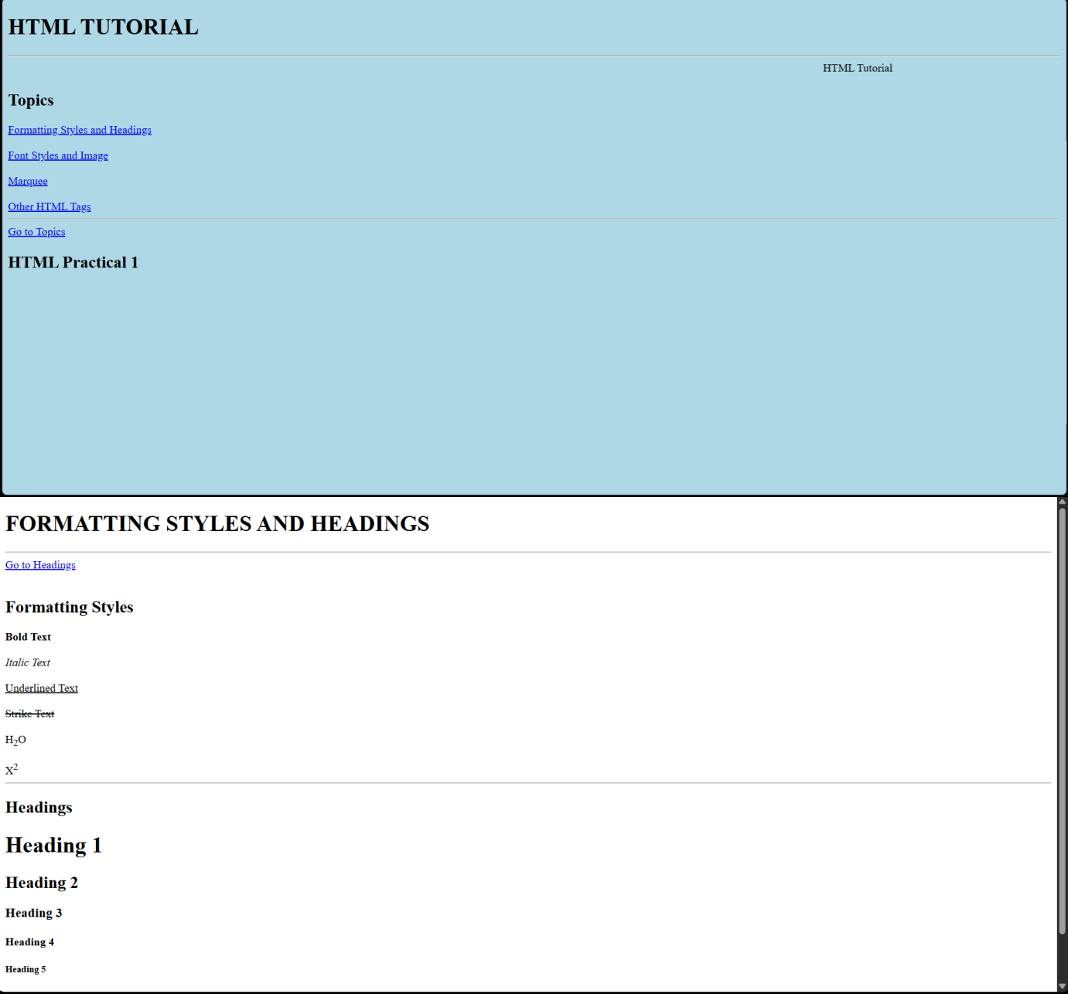

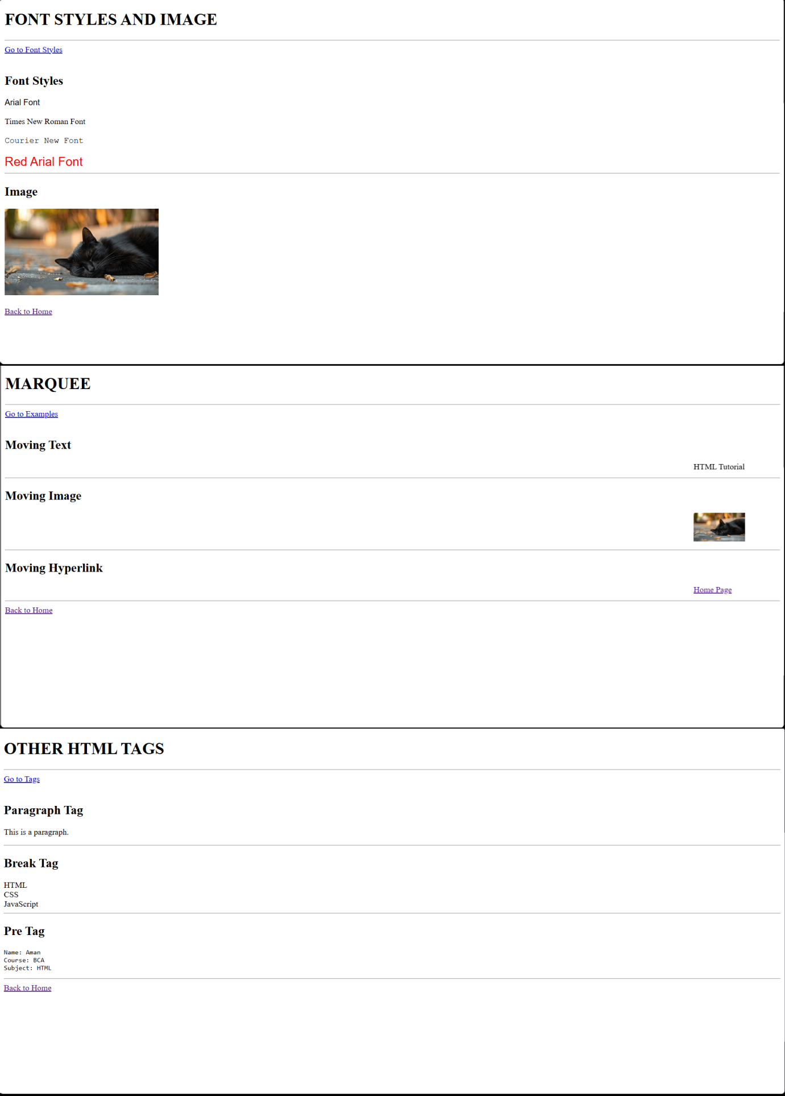
Q2: Create an unordered list nested inside ordered list and apply the following:

- Insert an image of Main item on top right corner of web page.
- Display heading as a marquee.
- Use different font styles and colors for different ordered list items.
- Insert horizontal line after each ordered item.

ANS:


